

Northampton Community Grant Fund

Guidelines and Application
Community Grant Fund Guidelines
The Community Grant program will be available twice a year for funding requests to assist with community events and projects.

 | Round 1 | Round 2
Applications Open | August | February
Application Closes | September | March
Assessment | October | April
Outcome | November | May

Applications will be considered by the Community Grants Advisory Committee. The award of funding for each round is at the absolute discretion of the Council.

Who can Apply?
Community groups and not-for-profit organisations may apply for funding for projects and events that have a target focus which benefits communities within the Shire of Northampton.
Prospective applicants should approach the Shire of Northampton Community Development Officers initially to discuss eligibility for funding an event or project.

Criteria
- To support the community to improve liveability, support, connectedness and participation by evolving the sense of community.
- General community projects and financial hardship support for Community groups.
- Youth and Senior initiatives.
- Events that benefit the district.
- Skills and capacity building in the community.
Eligible
- Not-for-Profit organisations.
- Incorporated associations / or an incorporated auspicing group.
- Have spent and acquitted any existing funds from the previous grant round.
Ineligible
- Government agencies: Generally, Government departments such as schools are not eligible for funding under this program; however, proposed school-based projects which have a strong broader community benefit may be considered.
- Businesses and individuals who intend to gain a personal advantage from the grant.
- Tourist-based contributions (other than events).
- Projects that are deemed to be of benefit to a business, person or other profit-making ventures.
Funding cannot be used for
- Retrospective costs for activities, or activities which will start before the applicant is notified of the outcome.
- Ordinary Shire business will be considered as part of Council’s normal annual budget process.
- Recurrent operational or staffing costs.
- Gifts or the purchase of alcohol or tobacco.
- Equipment not directly related to the project.
- Projects that are the core responsibility of government agencies.
What if I am Successful
You will be notified of the Council's decision. You may be required to do additional steps to fulfil the grant requirements; these will be highlighted on your official letter from the Shire of Northampton.

What if I am Unsuccessful
You will be notified of Council's decision. If you would like feedback, please contact your local Community Development Officer.

Grant Payment
Payment of grant funds will be made prior to the event/ project commencing. Successful applicants are required to present a Tax Invoice to the Shire of Northampton, with the following information
- Name of the group applying for the grant
- Name and year of the grant awarded to the applicant
- Descriptive Name of your project
- GST status, including your ABN
- Bank Details

Acquittal Requirements
- Acquittal of all granted monies must be completed and submitted using an acquittal process provided by the Shire by no later than twelve months from the notification of grant success.
- Recipients are required to fill out the acquittal form and provide a completed copy of the “Itemised Statement of Expenditure”.
- Recipients are required to provide copies of a tax invoice with a zero balance as proof of expenditure as per the amount granted as a funded item by the Community Grant Fund.
- Must demonstrate how the Shire of Northampton is appropriately acknowledged.

Feedback process
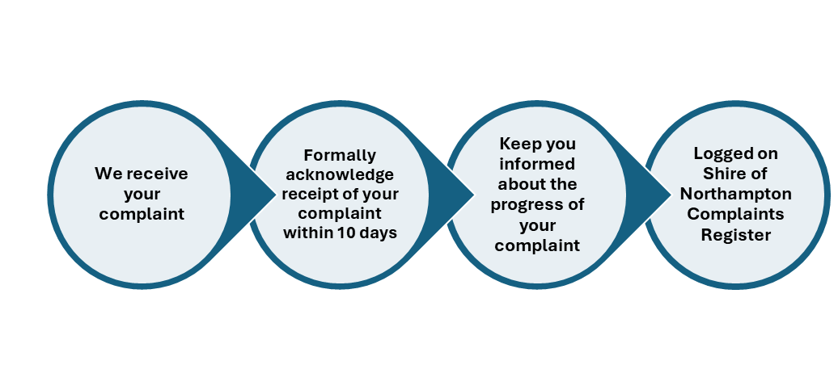We want to hear what you have to say about our grants process; your feedback will let us know what is important to you, as we continuously try to improve our services.
If you are unsatisfied with the outcome of your grant application, we encourage you to contact us; you can do so in person, by phone, or by email.
The Shire of Northampton is committed to effective complaint handling and values the feedback you provide. All complaints will be taken seriously, and we will do everything within our ability to resolve them. Complaints will be processed in accordance with the Shire's Complaints Policy.

Community Grant Fund Application Form
Please indicate which funding category you are applying for (if applying for more than one funding category, each category will require its own separate application form)
Category | Application funding | Amount  Ex GST
Category 1 | Community infrastructure and improvements | $4,000 | ☐
Category 2 | Youth program and community youth groups or seniors’ groups | $2,000 | ☐
Category 3 | - Events with broader target area | $5,000 | ☐
 | - Events with a more limited target area | $4,000 | ☐
 | - Events which are new and emerging | $3,000 | ☐
 | - One-off events celebrating a significant anniversary | $3,000 | ☐
Category 4 | Placemaking Grant (total pool $20,000).  Opens in round 2 | $20,000 | ☐
Category 5 | Partnership Grant (Total cash pool of $10,000) plus 25 hours of Community Development Officer support. Opens in Round 2 | $10,000 | ☐

Project and Applicant information
Project / Event Title:
Name of Organisation:
Date of Event / Project: | Start date: | Finish date:
Name of Primary Contact:
Email: | Phone:
Postal Address:

Organisation Information
Are you run solely by volunteers or a combination of paid and volunteer staff? | Yes ☐ | No ☐ | Both ☐
Are you saving for a larger project for the future? – if yes please provide details:

What category best describes your organisation
☐ Sporting Group ☐ Creative – arts
☐ Community Group ☐ Not-for Profit organisation
☐ Tourism ☐ Cultural interest
☐ Historical ☐ Other
Who is your target audience/ participants?
☐Youth and children ☐Seniors 65+
☐Culturally Diverse groups ☐People with disabilities
☐LGBTQ+ communities ☐Volunteers
☐Underserved and low-income communities ☐Families

Taxation Details
Is your organisation registered for GST? | Yes☐ | No☐
Please provide your ABN Number
Is your organisation not-for-profit? | Yes☐ | No☐
Is your organisation incorporated? | Yes☐ | No☐
Please provide your Incorporation Number
Please provide your annual audited financial statements | Yes☐ | No☐
For organisations that do not have audited financials: Attach the most recent income and expenditure statement, including current assets  (Bank balances minus any debts, Shares and Term Deposit accounts) | Yes☐ | No☐

If not incorporated, please provide details of the auspicing organisation
Name of Organisation:
Contact Person:

Contact Email/phone:
Incorporation number:
Organisation ABN:
Project / Event information
Brief overview of the event/project. 50 words or less

How will this project/event benefit the community: Outline a minimum of one objective.
☐ 1. Economic – Progressive, resilient and diverse economy.

☐ 2.Social – Enhance belonging and pride, welcoming and inclusive community.

☐ 3. Health and wellbeing – more people are mentally and physically healthy

How will this project/ event evaluate its success? E.g. Number of attendees, outcomes achieved.

Funding Details
Has your organisation previously received funds from the Shire of Northampton? If yes, please complete the following.
Yes ☐ No ☐ Unsure ☐
Year | Purpose of the funding | Amount received | Acquitted

Income
Contribution from | Cash | In-Kind (volunteer labour @ $37 p/h) | Confirmed Funds
Clubs’ contribution
Shire of Northampton
Sponsorship
Other grants
Fees & charges eg stalls
Gate/Door entry fees
Other
Total

Expenditure
Item | Amount  Inc. GST | Quote
Total

APPLICATION CHECKLIST
☐ The budget page has been completed, with your income and expenditure.
☐ ABN has been supplied or a Statement by a Supplier form completed.
☐ A copy of your Incorporation Certificate has been attached.
If you are not incorporated, please provide a copy of your
☐ Incorporation Certificate of your auspicing organisation.
☐ Umbrella Organisation copy of Charity Registration.
☐ Confirmation from auspicing organisation has been supplied (if applicable).
☐ Copies of the last two annual financial statements have been attached (for incorporated bodies).
☐ For organisations that do not have audited financials or are not incorporated: Attach the most recent income and expenditure statement, including current assets (Bank balances minus any debts, Shares and Term Deposit Accounts)
☐ Supporting documents (quotes, letters of support, etc.) have been attached.
☐ A complete copy of the application has been retained for your records.
☐ All questions have been responded to. Incomplete applications may not be considered.
If you are applying for more than one Shire Community Grant:
☐ A separate application form has been completed for each grant request.
☐ Indicate which grant request has the highest priority:

DECLARATION
I, the undersigned, certify that I have been authorised to submit this application and that the information contained herein and attached is, to the best of my knowledge, true and correct. I have noted the above requirements and agree to abide by them.
Name:
Position Held:
Signature: |  | Date:

Forward your completed application by 4 pm on the advertised closing date to:
Community Development Officer or by email to: council@northampton.wa.gov.au
Shire of Northampton
PO Box 61, NORTHAMPTON WA 6535

